Assignment 1A
Create a project on code blocks. Then enter the following program. Make sure to include the block comment but replace your name for mine. Also make sure to have proper indentation (use the tab key for indentation) and neatly written code. Compile and run it.
Follow the syllabus guidelines for submission.
// *******************************************************************************
// Assignment 1: Fortune Teller Program
// Author : Caterina Pentcheva
// Description : This program prompts the user for their age, calculates how
// old the user would be in a year, and displays it on the screen
// Status : Complete
// Date : January 1, 2013
// ********************************************************************************
#include <iostream>
using namespace std;
int main()
{
int age;
int new_age;
cout << "Please enter your age::: " ;
cin >> age;
new_age = age + 1;
cout << "Next year you will be " << new_age << " old.\n";
cout << "Thank you for using my program!" << endl;
return 0;
}
For Assignment 1B and 1C follow the guideline for assignment 1A
Assignment 1B
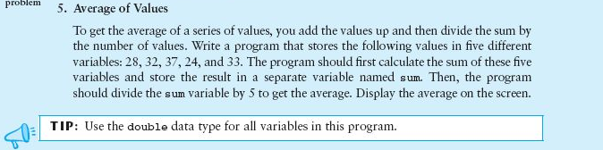
Assignment 1C:
